# Software Design Document

Real Neat Application

By: Anahit Hovhannisyan, Josh Standerfer, Nick Passantino

Capstone

Version 0.2

### Table of Contents

**Software Design Document** **1**

Table of Contents 2

**INTRODUCTION** **3**

1.1 Purpose 3

1.2 Scope 3

**System Overview** **4**

2.1 Use Case Diagram 4

2.2 System Diagram 5

**System Components** **6**

3.1 Decomposition Description 6

3.1.1 Sequence Diagram for General Algorithm 6

**Software Tools** **8**

C++ 8

Qt 8

Vienna RNA Package 8

4.3 Requirements Traceability Matrix (RTM) 9

**APPENDIX** **10**

A1 Definitions, Acronyms, Abbreviations 10

A2 References 11

# 

# INTRODUCTION

## 1.1 Purpose

This document is intended to discuss and describe the structure and architecture of the [RNA] software. By cataloging these features future changes and modifications can be more easily incorporated into the software.

## 1.2 Scope

This document attempts to capture the entirety of the structure of the software. There are several diagrams to demonstrate the implementation of features.

# 

# System Overview

## 2.1 Use Case Diagram

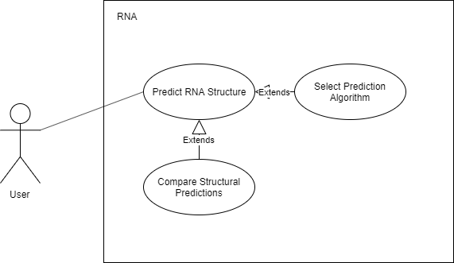

## 2.2 System Diagram

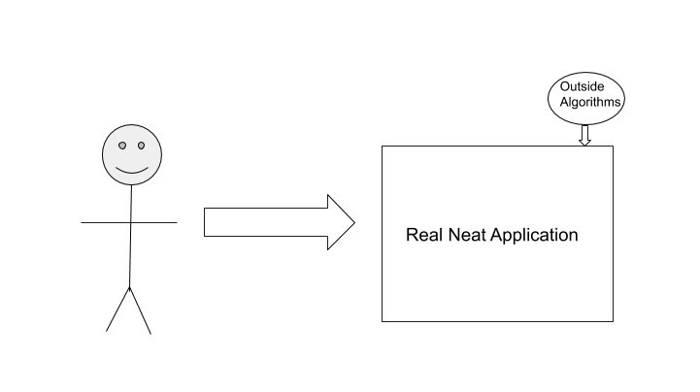

# System Components

## 3.1 Decomposition Description

### 3.1.1 Sequence Diagram for General Algorithm

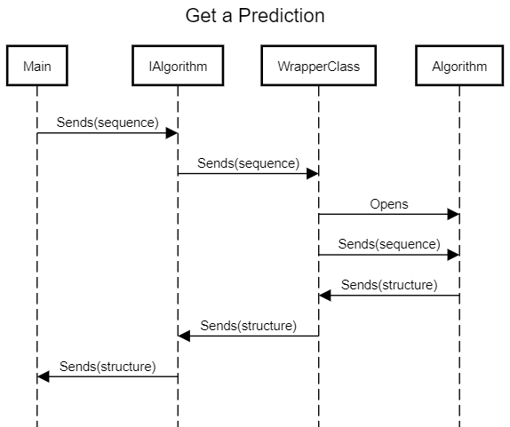

3.2 User Interfaces (GUI)

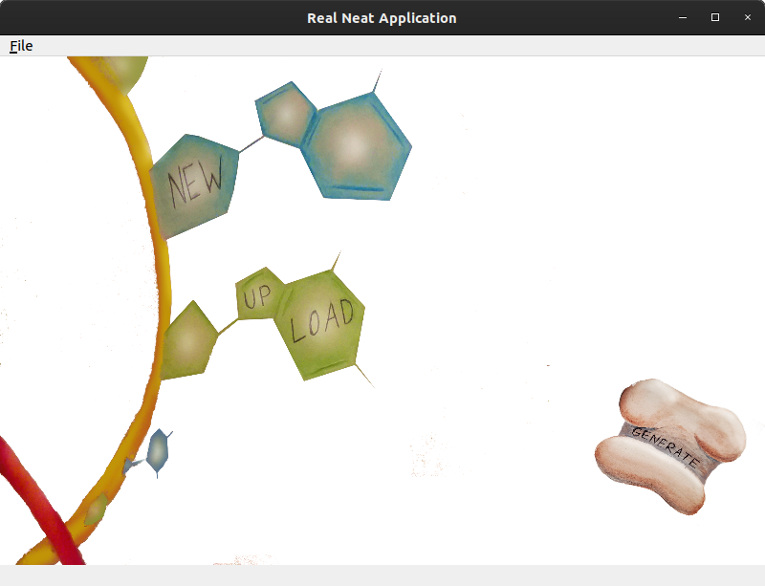

The main screen of the application will be a greeting screen which displays several options to the user. The presented buttons allow a user to specify an RNA sequence by hand, or to upload a FASTA or text file specifying a sequence. In the upper left corner of the window, a File menu allows the user to configure options for generating the structure, such as which algorithm they want to use and the directory they would like the structure file to be saved to. Once the requisite options have been seleted, the “Generate” button sends the sequence to the chosen algorithm to have a structure generated, and a graphical representation of this structure pops up in a new tabbed window.

# 

# Software Tools

## C++

Many of the other tools used, including some of the core algorithms for RNA secondary structural prediction, utilize C or C++. C++ will be the language primarily used to build this platform in order to most easily interact with these external libraries and softwares.

## Qt

A framework for developing cross-platform applications. The Qt creator is an all-in-one IDE which uses the Qt library to build applications. Qt is especially suited to developing UI using its ‘Signal and Slots’ to manage events. Being written in C++ is also advantageous due to flexibility and compatibility with many of the prediction algorithms available. The [RNA] is developed using the open source release of Qt, and is subject to its terms and conditions under the GNU General Public License.

## Vienna RNA Package

An RNA secondary structure prediction package written in C. This package is required by at least one other prediction algorithms.

## 

## 

## 4.3 Requirements Traceability Matrix (RTM)

|  |  |  |  |
| --- | --- | --- | --- |
| Req. # | Requirement | Remarks | Test Case Number |
| 3.2.1 | Generating RNA Model |  |  |
| 3.2.2 | Upload RNA File to Generate Model |  |  |
| 3.2.3 | 2D Model Algorithm Choice | Allow user to choose algorithm from supplied algorithm plug-in |  |
| 3.2.4 | Estimating Model job Time |  |  |
| 3.2.5 | Add and Remove Plug ins |  |  |

# 

# APPENDIX

## A1 Definitions, Acronyms, Abbreviations

Base Pairs: A set of two complementary nucleotides which form hydrogen bonds. A and U form a pair, C and G form another. The pairing AG, or UC cannot exist. This restriction is one of the driving forces of RNA structure formation, and is responsible for the complex forms that can be created. The bond of the CG is stronger than the bond between AU. Note: Bases adjacent to each other in the chain are not base pairs, any base can be adjacent to any other.

Dot-Bracket Notation: A simple way to express secondary structures. The simplest style uses ‘.’ to denote unpaired bases, and ‘(‘ ‘)’ to denote paired bases. There must be a closing bracket for each opening bracket. For example: ..(((((....))))).. Would indicate a structure of 4 unpaired bases in the center of the chain with the preceding 5 bases being paired with the succeeding 5 bases. Many programs generate this notation as output because it is simple with low-memory requirements.

Free Energy (Gibbs Energy): A common method for predicting RNA shape includes calculating the minimum free energy present in the structure. It is sufficient for this document to liken free energy to gravitational potential energy; if a branch is heavy enough to fall off to break off of a tree, it will. In the same way, if the electrostatic forces between some set of unpaired bases is greater than the forces holding some other set of base pairs together, the molecule will rearrange itself until the energy of the unpaired bases is the lowest it can be.

Hydrogen Bonds: Strong electrostatic attraction between hydrogen, and some other species. The formation of a hydrogen bond is not considered a chemical reaction, there is no change in chemical formula. To give an example, hydrogen bonds are responsible for water tension, yet we would not consider the entire mass of a lake to be a single molecule.

Nucleotides: Often referred to as ‘bases’ in the context of RNA, nucleotides are specialized molecules which form the structure of RNA. This document primarily deals with 4 nucleotides: A, G, U, C. To understand how RNA forms structures, it is vital to know that nucleotides form pairs, also known as base pairs.

Ribonucleic Acid: Abbreviated as RNA, is a molecule ubiquitous in biological functions. RNA is constructed from chains of nucleotides. An RNA sequence may be similar to the following: AUCGCGUAGCAUGC.

## A2 References

Lorenz, Ronny and Bernhart, Stephan H. and Höner zu Siederdissen, Christian and Tafer, Hakim and Flamm, Christoph and Stadler, Peter F. and Hofacker, Ivo L.

ViennaRNA Package 2.0

Algorithms for Molecular Biology, 6:1 26, 2011, [doi:10.1186/1748-7188-6-26](http://dx.doi.org/10.1186/1748-7188-6-26)

Sato, K., Kato, Y., Akutsu, T., Asai, K., Sakakibara, Y.: DAFS: simultaneous aligning and folding RNA sequences via dual decomposition. Bioinformatics, 28(24):3218-3224, 2012.